## About AI Editor

Q1

What is an AI editor and what is an AI installer

A

AI Editor is a tool for editing AI behavior for the game.

Installer is done for the editor AI AI files fast installation tools to the game directory.

Q2

After I edit the pop-up tech window, do I need to do it again on the Tech tree page, or can I just close it?

A.

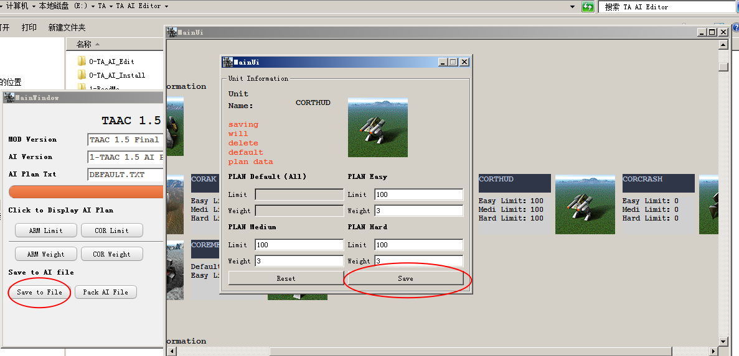

When you click on the unit icon, you can open the unit editing page, where there is a save button, click Save to save the data.

Closing the Tech page window does not make the saved data disappear.

However, please note that this is only a temporary save and the data will be lost after closing the main page.

To save permanently, click Write to File on the main page.

After successful overwriting, the next time the AI scheme is opened, the contents saved last time will be re-read from the file.

Q3

Are the parameters set are the same to all factories?

A

Yes, because TA different factories can build the same class, such as sea aircushion factory and land aircushion factory build menu is exactly the same, engineering aircraft and engineering vehicles can build level 1 solar, the same weight and quantity for all units is global. it did not distinguish each by type of factory, but simply counted the total number built.

Q4

The TA33B custom AI will not build giant spiders and sea and land vehicles and ScorpionKing

A

1.

These are all transportation units. The fbi file have **canload=1**

My test is that the computer does not build shipping units with **canload=1** by default

I have no idea why computers don't make transportation units, and how to make computers make transportation units

2.

The original TA33B AI produced the spider because it did not include these two lines in its AI text

**limit core 0**

**limit arm 0**

Having these two lines actually controls that units that are not in the Ai text are not built

Without these two lines, the computer will start creating units that are not in the AI text, which is two spiders: aiFatShrew and aicormkl

Computer built spiders are not actually players' spiders (FatShrew and cormkl)

Is another spider that cannot load (canload=0) (aiFatShrew and aicormkl)

## About Maps

Q.1

With so many AI files, how do I know which map uses which ai file

A.

They have a lot of maps, but they're regular

General maps use DEFALUT.TXT by default

Amphibious maps mainly use HOVER beginning

Naval battle maps usually start with the SEA

METAL maps are usually metal or Krogoth

AIR combat maps usually start with AIR

The AI used for campaign MISSIONS is missions.txt

If you are really unsure, please open the map with TA map editor, and you can view the configuration of this map in the parameter configuration

Q.2

About AI files, can I change a DEFAULT.txt, directly take to copy to all other ai files?

A.

Each map corresponds to different terrain Settings, and the construction of the corresponding arms should be different.

The sea battle map is not suitable for land battle mode, and the air battle map is not suitable for land battle mode

The suggestion is to change the file of this map type separately when you want to play which map type, modify only one file each time, modify the AI file several times, and finally complete the entire AI scheme.

The city map is generally of the urban type, and this map is generally rare in mineral points, but there are a lot of recoverable resources. On this map, the number and weight of level 1 mineral points should not be set too much, but the priority of solar energy and converters should be increased. The ratio of solar energy to the number of converters is a multiple of 3 or 5

## About AI

Q.1

About the AI Plan I found two different metal mines or units that the player can't build, what's the difference? How should I set it?

A.

The mine building you found is probably the AI unique resource building that comes with this MOD version.

You can control the number and weight of this building to greatly change the AI resource bonus.

The specific amount of resources this building comes with you need to check in the game, because different mods and AI schemes will be set up differently

Here's a quick rundown of what we know

**TAAC1.5 official**

Without any AI-specific architecture,

AI intensity is very low

**TAAC1.5 AI Scheme 1**

ARMCHEAT Land AI unique architecture

ARMUWCHEAT undersea AI unique architecture

CORCHEAT Land AI unique building,

CORUWCHEAT underwater AI unique building

resource Adds up to 20 metals, 160 energies

Plan 1 sets the number to 1,2,3 according to the difficulty level

Suitable for new player from easy to difficult ladder challenges

**TAAC1.5 AI Scheme 2**

Except that it is basically the same as scheme 1, adding a factory

ARM ArmAIHKLab

CORE CORAIKargant

The construction efficiency of this plant is equivalent to that of five ordinary Level 3 plants

When AI produces this factory in the middle and late stages, it can help AI focus on building advanced units.

Of course, this version of AI will often fall into the situation of insufficient metal and insufficient energy, which will greatly limit his production capacity, and do your best to attack the mine and nuclear power of AI

Suitable for players who want to pursue challenge, but not too much.

**TA33B official**

ARMCHE Land AI unique architecture

ARMCHEU undersea AI unique architecture

CORCHE Land AI unique architecture

CORCHEU undersea AI unique architecture

Resource bonus - You can think of it is huge amounts

Pure official version, experience the classic version of AI brought shock

**TA33B AI Scheme 1**

ARMCHE Land AI unique architecture

ARMCHEU undersea AI unique architecture

CORCHE Land AI unique architecture

CORCHEU undersea AI unique architecture

Modified the military plan to try a fresh feeling

**TAESC 996 official**

No AI exclusive buildings

ESC has its own difficulty level,

Simple AI has no resource bonus

Medium AI mine 2x resources, energy harvester 2x

Hard AI mine 4x resources, energy harvester 4x

AI strength is generally suitable for beginner players

**TAESC 996 Scheme 1**

ARMCHEAT Land AI unique architecture

ARMUWCHEAT undersea AI unique architecture

CORCHEAT Land AI unique building,

CORUWCHEAT underwater AI unique building

Resource bonus - You can think of it is huge amounts

This AI will not build resource buildings, simple and rough...

**TAESC 996 Scheme 2**

ARMCHEAT Land AI unique architecture

ARMUWCHEAT undersea AI unique architecture

CORCHEAT Land AI unique building,

CORUWCHEAT underwater AI unique building

- Simple, AI economy +20 metal +2000 energy

- Medium, AI economy +40 Metal +4000 energy

- Hard, AI economy +80 metal +8000 energy

Because AI often makes more money than it earns, hitting the economy will seriously affect AI production in the later stages

Difficulty - Experience varies according to player level

## About Editor design

Q.1

How is the editor file directory organized

A.

As follows

3-MOD **#MODs are stored here**

├─TA 33BN **#MOD version TA33b**

│ └─1-TA 33BN official **#33b AI official** **version**

│

├─TA ESC 996 **#MOD version ESC 996**

│ │

│ ├─1-TA ESC 996 official **#996 AI official** **version**

│ │

│ ├─2-TA ESC 996 Scheme 1 **#996 AI Scheme 1 version**

│ │

│ └─2-TA ESC 996 Scheme 2 **#996 AI Scheme 2 version**

│

└─TAAC 1.5 **#MOD version TAAC1.5**

│

├─1-TAAC 1.5 official **#TAAC AI official** **version**

│

├─2-TAAC 1.5 Scheme 1 **#AI Scheme 1 version**

│

└─2-TAAC 1.5 Scheme 2 **#AI Scheme 2 version**

Q2

Do it need a profile? and where do I find one

A

Each MOD requires a different configuration file

Configuration files can be found in each mod folder under **3-mod**.

For example, the TA 33BN configuration file is in the

\TA AI editor \3-MOD\TA 33BN directory

For details about the configuration file format, see the editor documentation

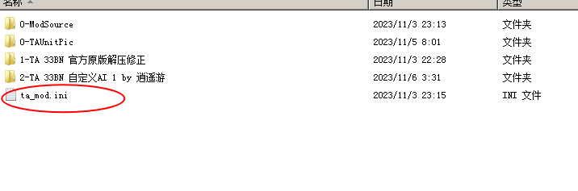

Q.3

I want to make my own AI scheme, how to create a new scheme

A. Go to the mod directory, such as the TAAC1.5 folder, and make a copy of it in the same directory as the other solution

TAAC 1.5

├─1-TAAC 1.5 official

├─2-TAAC 1.5 Scheme 1

└─2-TAAC 1.5 Scheme 1 COPY

Select the folder to copy, and rename, that is, a new AI solution

For example, copy 1-TAAC 1.5 Scheme 1 and rename the copied folder to the Scheme 2, the Scheme 2 is the new AI scenario that you can modify on it

Q.4

I want to add another MOD to the editor. How do I create a new MOD

A.

First, you need to understand how the editor works, and you can look at the instructions.

Here's an excerpt,

The main idea of this AI installation method is to separate the data files and AI files in the MOD to achieve a convenient operation of changing AI schemes at any time.

Take the TA33B as an example

ta33b.33b file contains only data files

Split 1

In the TA33b MOD resource file “TA33b.33b” contains data file and AI file

Split 2

In the second step, you need to create a new folder in the 3-MOD directory and name it with the MOD version number,name Like TA ESC 996

In the third step, you need to unpack the mod's resource files and separate out the following resources

Ai AI Text directory

Gamedata SIDEDATA.tdf in this directory

unitpics ICONS

After separation, all the remaining files that do not contain AI data are packed into resource files

The dir structure of TA33B is given below

├─TA 33BN

│ ├─0-ModSource **#resource file that stores separated AI data**

│ ├─0-TAUnitPic **#ICONS**

│ │ └─UnitPics **#** **Same as the original directory name**

│ └─1-TA 33BN official

│ └─33bn **#** **Note this directory**

│ ├─ai **#AI Text directory**

│ └─gamedata **#SIDEDATA.tdf**

**Please note SIDEDATA TDF is AI build file as many of the MOD of this file is incomplete or contains errors, it may take several hours to modify**

The ESC directory structure is given here as a reference

├─TA ESC 996

│ ├─0-ModSource

│ ├─0-TAUnitPic **#Because ESC scattered the ICONs among multiple Ufos**

│ │ ├─T2ESC **#same as T2ESC.UFO**

│ │ │ └─unitpicE

│ │ ├─T3ESC **#same as T3ESC.UFO**

│ │ │ └─unitpicE

│ │ ├─T4ESC1 **#same as T4ESC.UFO**

│ │ │ └─unitpicE

│ │ └─TXESC **#same as TXESC.UFO**

│ │ └─unitpicE

│ ├─1-TA ESC 996 official

│ │ └─TAESC

│ │ ├─aE

│ │ └─gamedatE

│ ├─2-TA ESC 996 Scheme 1

│ │ └─TAESC

│ │ ├─aE

│ │ ├─gamedatE

│ │ ├─scripts **#If you can add units to the game**

│ │ ├─unitpicE **#If you can add units to the game**

│ │ └─unitsE **#** **may require some game MOD knowledge**

│ └─2-TA ESC 996 Scheme 2

│ └─TAESC

│ ├─aE

│ ├─gamedatE

│ ├─scripts

│ ├─unitpicE

│ └─unitsE

Fourth, you need to follow the operation manual to add the corresponding MOD configuration to the editor and the installer, which can be referred to the parameter description section.

**SIDEDATA.tdf structure content brief description**

SIDEDATA.tdf specifies the build list of AI units.

The AI editor builds the interface and data mainly from the data within the SIDEDATA.tdf.

If the data is incorrect or missing, the in-game computer can't build the units it should, and the AI editor can't display the interface correctly.

You need to modify the SIDEDATA.tdf file according to the in-game menu that the player can create.

The following is the data structure of ARM Commander in SIDEDATA.tdf

[ARMCOM] **#ARM** **Commander**

{ **#canbuild=UnitName**

canbuild1=ARMSOLAR; **#SOLAR**

canbuild2=ARMMEX; **#Metal maker**

canbuild3=ARMLLT; **#Laser Tower**

canbuild4=ARMRL; **#Missile Tower**

canbuild5=ARMESTOR; **#energy storage**

canbuild6=ARMMSTOR; **#metal storage**

canbuild7=ARMTIDE; **#TIDE**

canbuild8=ARMMAKR; **#** **convertor**

canbuild9=ARMVP; **#vehicle**

canbuild10=ARMUWES;

canbuild11=ARMAP;

canbuild12=ARMUWMS;

canbuild13=ARMSY;

canbuild14=ARMSONAR;

canbuild15=ARMTIDE;

canbuild16=ARMRAD;

canbuild17=ARMUWMEX;

canbuild18=ARMFMKR;

canbuild19=ARMTL;

canbuild20=ARMCOMLVUP;

canbuild21=ARMWIN;

canbuild22=ARMSOLAR;

}